**Installation Guide for ALPHA release v.0.1.0**

1. During downloading the package from web, the .dll files might be blocked. In order to enable the dlls, please **right click** on each file and click **Properties**. Under “**General**” tab, on the bottom check if there is Security item appears, then Click **Unblock** button to enable the dlls.

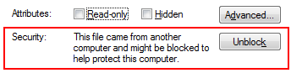

1. Before launch the Dynamo 0.7., copy all the files under the folder “**dlls/GBSforDynamo_UI**” into “**C:\Program Files\Dynamo 0.7\Revit_2014**”
2. Importing GBSforDynamo library: In Dynamo 0.7 window, go to “**Libraries**” tab and click “**Import Library…”** Select the “**GBSforDynamo.dll**” from “**dlls/GBSforDynamo**” folder. You need to repeat this step #2 each time whenever you open a new instance of Dynamo.



